Mr.Brando’s New Clothes Store
（A part from Stardust City Morning Radio）
Written by Ziyue Qiu

Good morning,everyone in this city! There is a new store at YOLO street. Here is an ad from it:
-----------------------------------------------------
Hello, my friends! Come and buy your clothes at our great sale! Do you like caps? We have caps in all colors for only four dollars! And we have many great buttons, one dollar for two buttons! For boys, we have T-shirts for seven dollars, and trousers are only six dollars! For girls, we have skirts in all colors for only five dollars! Socks are two dollars for three pairs! And-Do you know Kujo Jotaro? We have all kinds of his caps from Stardust Crusaders to Stone Ocean! That’s not all, come to Mr.Brando’s Clothes Store NOW!
-----------------------------------------------------
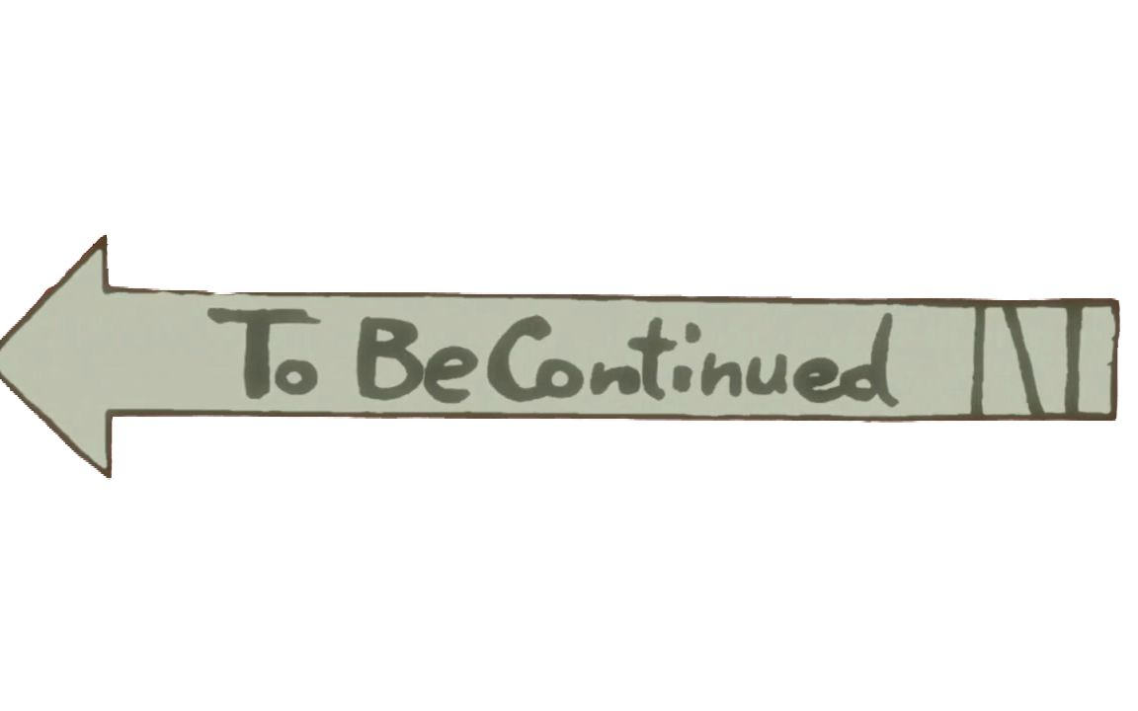
OK. If you have time, you can have a try at that store. Now, let’s have some news, OK?

